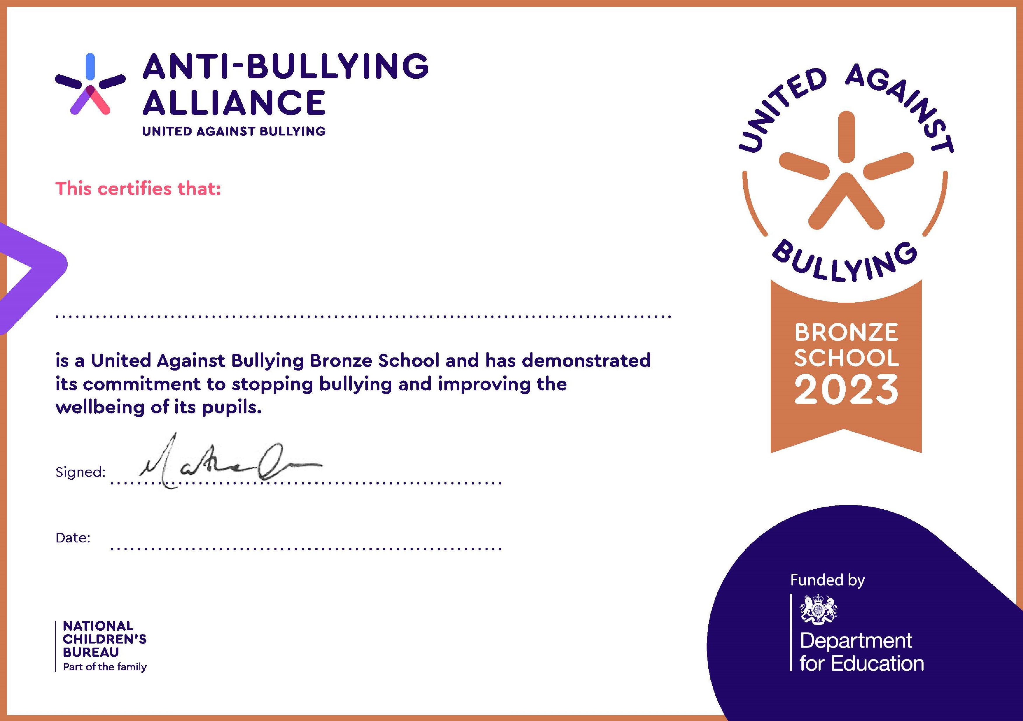
Newlands Junior School
23
rd
August 2023

