Year 3 | Genres covered during the year | Stone Age to Iron Age | Egypt | Local History (mining)
Other Texts | Autobiography (PSHE)  Play scripts  Diary (the Egyptian pyramids)  Tension/setting description, narrative (Tadeo Jones)  Red Miss Take:  -instructions  -invent a character  -recipes  -narrative, dialogue, write ending  The shirt machine:  -draw/label plans for the machine  -list components  -write instructions for the machine  -design shirts  - write adverts  -describe special items of clothing  -explanation of the how the machine works | The Settlers (Emeralds) Serial Mash | Beth on the Nile (Emeralds) Serial Mash | The Knockers (Emeralds) Serial Mash
FILM |  |  | The Egyptians (the history shed)  - Tadeo Jones  - The Egyptian pyramids | Red Miss Take (the inventors’ shed)  The shirt machine (the inventor’s shed)
Images |  | 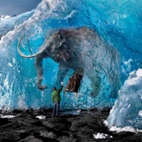  Image and story starter from Literacy Shed: Slowly, a foot moved, then the trunk, then a loud growl shook the cavern... |  | 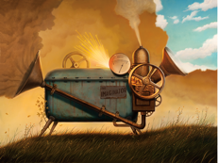  The Imaginator (Once upon a picture). Prompts too.

 | Invaders and Settlers | European Study | World War Two
Other Texts | A horde of ravens (Sapphires) Serial Mash | The Sleeping Volcano (Emeralds) Serial Mash | A bridge on fire (Sapphires) Serial Mash  Buster’s Blitz (Sapphires) Serial Mash
FILM | How to train your dragon  Dum Spiro (the history shed)  Jotun – journey of a Viking (history shed)  A Viking village (the history shed)  The saga of Biorn (myths/legends shed)  King Midas (myths and legends shed)  Arachne (myths and legends shed) | Emile Sande – Free (the music video shed)  The Ridge (the sports shed)  Dreadful menace (the sports shed) | Germans in the woods (the inspiration shed)  The Piano (the inspiration shed)  The Blitz (war and peace shed)  Beyond the lines (war and peace shed)  The Rocketeer (war and peace shed)
Genres covered during the year
Films | Letters (recount)  War letters:  Beyond the lines  Germans in the woods  The Rocketeer  Diaries/recount (Germans in the woods)  Speech (Churchill)  Advert – persuasive (travel brochure)  Instructions (How to train your dragon) | Narrative:  Narrative opener (Dreadful menace)  Narrative (The Ridge)  Description/narrative (Jotun)  Description (Viking village) – create a map of the village too  Recount (The Ridge)  Narrative with flashbacks (Germans in the woods)  Adventure story, narrative from different points of view (The Rocketeer) | Newspaper:  Germans in the woods  The Rocketeer  Wanted poster (The Rocketeer)  Poetry:  Dreadful menace  The Ridge  Beyond the lines
Images | 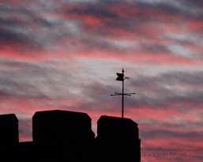  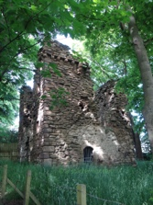  Castle siege. Starter for ten – writing prompt.  Siege tower. Starter for ten – writing prompt.  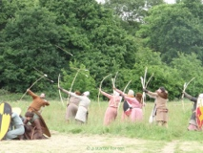  Archer. Starter for ten – writing prompt.  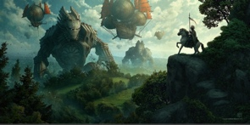  The invasion – Pobble365 |   An uphill struggle – Pobble365  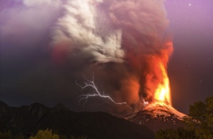  Volcano – Pobble 365  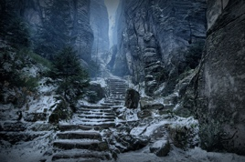  The mountain pass – Pobble365 | 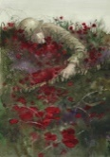  Remembrance (Once upon a picture). Prompts too.  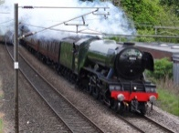  Evacuees.    Starter for ten – writing prompt.    Desert combat. Starter for ten – writing prompt.  Memories – Pobble365
Year 5 | North and South America |  | London
Other Texts | Just the beginning (Sapphires) Serial Mash  Serpents of the Nebula (Sapphires) Serial Mash  Silver secrets of the Golden Hind (Sapphires) Serial Mash  A dark night on the prairie (Sapphires) Serial Mash  Rivers of the World (Twinkl self-marking reading comprehension)  Rainforest Deforestation (Twinkl self-marking reading comprehension) |  | Suffrajitsus (Sapphires) Serial Mash  Female Engineers (Twinkl self-marking reading comprehension)
FILM | Hunted (the fun shed)  Day of the Dead (the mystery shed)  The Day of the Dead information film  Aviatrice (the history shed)  A cloudy lesson (the inventor’s shed)  Water cycle animation (non-literacy shed)  John Henry: American tall tale (myths & legends shed)  Ride of passage (other cultures shed)  Hugh (other cultures shed)  Swing of change (the thinking shed) |  | Pudding Lane (the history shed)  Derby Day (the history shed)  Not a film, but a website: A London literary tour for kids on www.diaryofalondoness.com
Genres covered during the year
Films | Non-Chronological report:  Creature  Day of the Dead  Ride of passage – tribes/animals  Explanation:  Derby Day – the Suffragettes  Cloudy lesson  Newspaper:  Immigration  Pudding Lane  Derby Day  Cloudy lesson  Hunted  John Henry - slavery | Recount (Derby Day, Ride of passage)  Narrative:  1st person narrative (Pudding Lane)  Description (Derby Day)  Direct/indirect speech (Aviatrice, Cloudy lesson, Ride of passage)  Setting/character description, inner monologue (Swing of Change)  Write own myth (Hugh)  Diary:  Day of the Dead  Pudding Lane  Ride of passage |  | Speech for London Tour bus (commentary)  Balanced argument (deforestation)  Advert (Iceland–Rang Tan)  Biography/formal language (Aviatrice, John Henry)  Play scripts  Instructions (Cloudy lesson)  Invent ways of making other natural phenomena (Cloudy lesson)  Letter (Ride of passage, Hunted)

Year 5 | North and South America | London
Images | A new world – Pobble365.  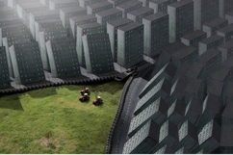    The world in your hands – Pobble365.  Save our habitat – Pobble365  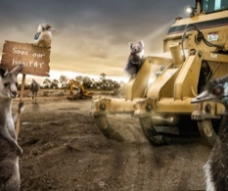  New York is falling – Pobble365.  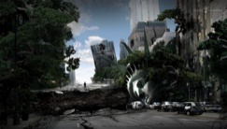 | 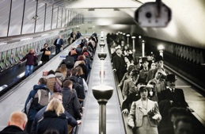  Then and Now – Pobble365

Year 6 | The Victorian Era |  | Crime and Punishment
Other Texts | An invasion of Navvies (Emeralds) Serial Mash  Ollie and the Great Stink (Sapphires) Serial Mash  Pit Boys (Sapphires) Serial Mash  Florence Nightingale (Twinkl self-marking reading comprehension)  Fossils (Twinkl self-marking reading comprehension) |  | Mary Anning and the Time Twister (Emeralds) SM  Cyber Crime Files (Sapphires) Serial Mash  The Snatch (Sapphires) Serial Mash  Secret Agent Grandpa (Sapphires) Serial Mash  The Northern White Rhino (Twinkl self-marking reading comprehension)  Pirates (Twinkl self-marking reading comprehension)
FILM | Victorian diaries (the history shed)  1. School days.  2. Upstairs, downstairs.  3. Strike  4. Down but not out.  5. Final chapter  Charles Dickens Biography (the history shed)  Girl and robot (the inventor’s shed)  Wing it (the inventor’s shed)  The Alchemist’s letter (myths and legends shed)  Not a film, but a website: Queen Victoria’s Scrapbook: http://www.queen-victorias-scrapbook.org/index.html |  | The facts in the case of Mr. Hollow (mystery shed)  Chaperon Rouge (fairy tale shed)  Maux dits (fairy tale shed)  The three little pigs (fairy tale shed)  Alma (the ghostly shed)  Swing (the sci-fi shed)  Ruckus (a shed full of animations)
Genres covered during the year
Films | Newspaper reports:  The three little pigs  Maux dits  Chaperon Rouge  Mr. Hollow  Wing it – great flying machine  Ruckus  Wanted poster (Alma, Ruckus)  Police report (Mr. Hollow)  Eye-witness reports/point of view (Ruckus) | Biography  (Charles Dicken, Queen Victoria, inventor – Wing it)  Non-chronological report (inventions – Wing it)  Explanation:  Invent flying machine, label how it works (Wing it)  Design own rocket and label (Girl and robot)  The Alchemist’s machine (The Alchemist’s letter)  Instructions (Wing it – for building a robot)  Diary/Journal (Girl and Robot)  Recount (Wing it, The three little pigs, Ruckus)  Play script (Mr. Hollow) |  | Narrative:  Write a sequel (Alma)  Dialogue between aliens, description (Wing it)  What happens next? (Girl and Robot)  Flashback/forward, narrative, dialogue (Mr. Hollow)  Own versions of fairy tales (Chaperon Rouge)  Story about the next victim; what could be in the tree, describe the death scene (Swing)  Re-write as a narrative, dialogue, setting/character descriptions (Ruckus)  Description of home, dialogue, story in same style, alternative ending, 1st/3rd person narrative (Maux dits)
Year 6 | The Victorian Era |  |  | Crime and Punishment
Images | 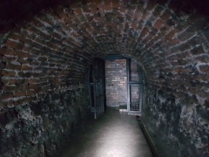  Victorian prison. Starter for ten – writing prompt.  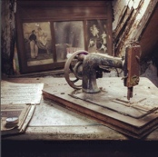  New sewing machine.  Starter for ten – writing prompt.    The end of technology – Pobble365    The Alchemist – Pobble365    Owliver Twist – Pobble365    Workhouse musician – Pobble365  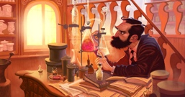  Professor Plum – Pobble365 |  |  | 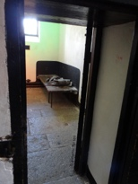  Starter for ten – writing prompts.  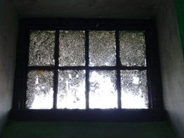  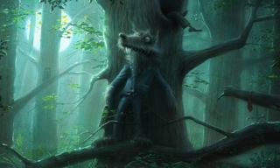  Mr. Wolf – Pobble365

