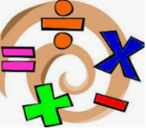

**Maths**

* 2D & 3D shape
* Division
* Fractions & angles

During every lesson, we will be developing our reasoning and problem solving skills through a range of challenges.

We will be having daily revision sessions, times tables and arithmetic lessons. Additionally, we will continue to have regular active maths sessions.

**Citizenship & Wellbeing**

We will be looking at self- worth, friends, democracy and health, wellbeing and hygiene. We will also take part in E-Safety Week and will learn to keep ourselves safe on the internet.

Mental health is of vital importance to us and we will be using relaxation techniques to help us overcome a range of emotions that we may feel. It is our belief that if we equip children with the knowledge to understand their emotions, they will develop into more resilient, happy individuals.

All of our subjects, wherever possible, will interweave with our geographical focus of Egypt. In history, we will be looking at who the pharaohs were, their beliefs and how we can use artefacts to learn about the past and link this to our lives today and in the future. In science, we will be learning about plants and will be carrying out a number of investigations. In RE we will look at Lent and who were the 12 disciples.

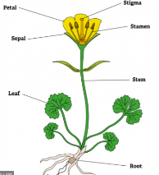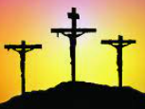

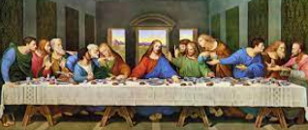

**English**

**Writing**

We will be writing:

* An **adventure story** based in Egypt and an **information text** about the importance of the River Nile.
* A **newspaper report** about the discovery of a famous tomb
* A selection of shorter pieces within topic lessons

**Grammar & Punctuation**

We will be doing daily revision activities as well as Y3 grammar coverage, which will support our writing.

**DEAR**

Every day, in the afternoon, we **D**rop **E**verything **A**nd **R**ead. Children are welcome to bring books from home to share with their friends on these days.

**PE**

Year 3 will have at least two PE sessions every week. We will let you know at the start of each half term which days are PE days. Please make sure you send your child to school on these days in PE kit.

Over the term, we will be focussing on:

* Gymnastics
* Fitness circuits
* **Swimming continues at Rebecca Adlington until February half term**

**This Term, Year 3 children will be looking at the topic of**

**Egypt**

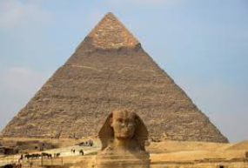

**Extra Information**

* **Every week children will be given one piece of Maths homework and one piece of English (usually related to grammar or punctuation) or topic. Homework will be given out every Friday, to be returned completed the following Wednesday.**
* **Spellings – Children will be given weekly spellings. They will be given these in their diaries every Monday.**
* **Times Tables – Children need to practise their current times table each week. Children will do weekly times tables tests.**
* **Reading – We expect children to read at least 3 times a week at home for at least 5 minutes. Reading diaries need to be signed and handed in every Monday.**

**Art**

We will be learning about:

* Textiles and collage to create an Egyptian headdress (Kurt Schwitters)
* Digital Media to create a motif (Hazam Taha Hussein)

**Close Reading**

This term, we will reading Beth and the Nile, as well as a number of non-fiction pieces and poetry associated with the topic of Egypt as well as other subjects.

We will be answering questions from the texts, using skills taught during lessons as well as lots of vocabulary work to develop understanding of the texts.

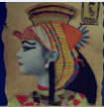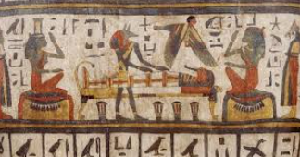

**Computing**

We will be learning about how to stay safe on the internet as well as using a programme to create graphs from data in a table.



**DT**

We will be cooking a

healthy stew, using

fresh ingredients and

learning about nutrition.

