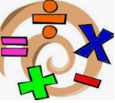

**Citizenship & Wellbeing**

We will be looking at self- worth, respect, families, democracy and charities. We will also take part in anti-bullying week.

Mental health is of vital importance to us and we will be using relaxation techniques to help us overcome a range of emotions that we may feel. It is our belief that if we equip children with the knowledge to understand their emotions, they will develop into more resilient, happy individuals.

**Maths**

* Place value
* 4 operations (+ - x ÷)

During every lesson, we will be developing our reasoning and problem solving skills through a range of challenges.

We will practise our times tables daily using times tables rock stars and other activities.

All of our subjects, wherever possible, will interweave with our historical focus of Early Man. In geography, we will be looking at where the first humans originated from and how they reached Britain, as well as looking at how they chose locations for settlements. In sciences, we will be learning about muscles and the skeleton as well as forces and magnets.

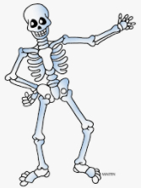





**English**

**Writing**

We will be writing for different audiences and purposes:

* A diary entry
* A recount
* Character description
* A persuasive text
* Narrative

**Grammar & Punctuation**

We will be doing grammar starters during our English lessons and teaching discrete Y3 grammar objectives.

**DEAR**

Every day, in the afternoon, we **D**rop **E**verything **A**nd **R**ead.

**PE**

Year 3 will have at least two PE sessions every week. We will let you know at the start of each half term which days are PE days. Please make sure you send your child to school on these days in PE kit.

Over the term, we will be focussing on:

* Fundamental skills (catching and throwing)
* Commando Joe – Character Education
* Tennis (taught by a coach)
* Gymnastics

**This Term, Year 3 children will be looking at the topic of**

**Early Man**

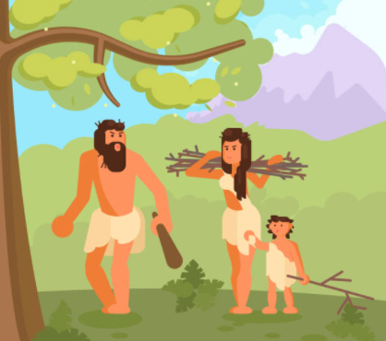

**Close Reading**

This term, we will be reading and studying The Settlers, which can be found on Serial Mash (Emeralds) as well as Stone Age Boy in English.

We will be answering questions from the text, using skills taught during lessons as well as lots of vocabulary work to develop our understanding.

**Extra Information**

* **Every week children will be given one piece of Maths homework and one piece of English (usually related to grammar or punctuation) or topic. Homework will be given out every Friday, to be returned completed the following Wednesday.**
* **Spellings – Children will be given weekly spellings. They will be given these in their diaries every Monday. These spellings will be tested every Friday.**
* **Times Tables – Children need to practise their current times table each week. Children will do weekly times tables tests.**
* **Reading – We expect children to read at least 3 times a week. Reading diaries need to be signed and handed in every Monday.**

**Art**

We will be learning about:

* Tile printing (Henri Matisse)
* Clay: The Beaker People (Bronze Age pots)

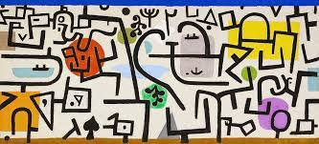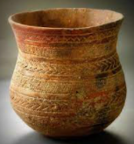

**DT**

We will be designing and constructing our own Bronze Age roundhouses and Stone Age tools.

**Computing**

We will be learning how to use search engines safely and effectively, as well as how to create a program using coding.

