**Computing**

This term we are looking at:

* Handling data and multimedia

**Science**

We are learning about:

* Rocks and soils
* Magnets and forces
* Light and shadow

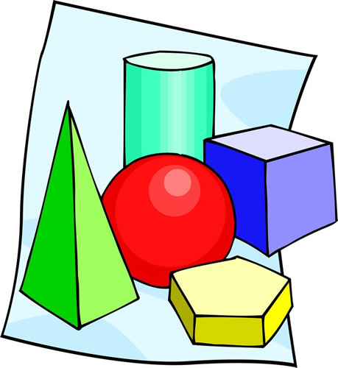**Maths** 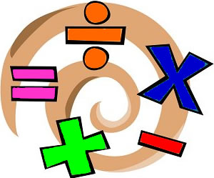

* Place Value
* (+ - x ÷) four operations
* Fractions
* Measurement
* Properties of shape
* Statistics

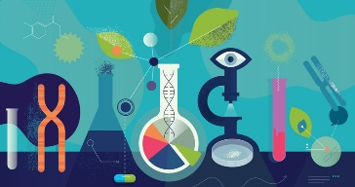



**English**

**In English this term, we will be looking at traditional tales**

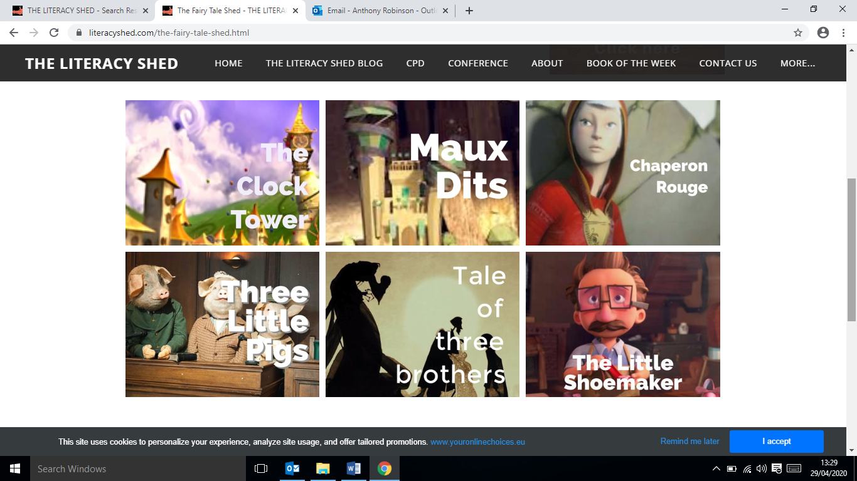

**We will be exploring characters and settings, using lots of descriptive language. Which will build up to us writing a fractured fairy tale. We will then look at writing a news report of our fractured fairy tale.**

**This Term Year 3 will be looking at the topic…**

**Coal Mining**

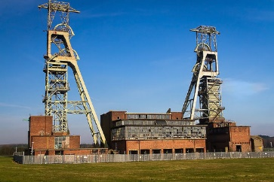

**We will be learning about our local area and the history of mining in Clipstone**

**PE**

**Y3 will be having weekly tennis sessions. They will also be looking at striking and fielding and athletics.**

**Music**

**We will be exploring chrome music maker and classical music**

**Extra Information**

* **Every week children will be given one piece of Maths homework and one piece of English (usually related to grammar or punctuation). Homework will be given out every Friday, to be returned completed the following Wednesday.**
* **Spellings – Children will be given spellings from the weekly spelling rule, the year 3/4 words and key topic words. They will be given 10 new spellings every Monday. These spellings will be tested every Friday.**
* **Times Tables – Children need to practise their current times table each week. Children will do weekly times tables tests.**
* **Reading – We would also like children to read at least 3 times a week at home for at least 5 minutes. Reading diaries need to be signed and handed in every Monday.**

**Close Reading**

In close reading this half term, we will be studying a text linked to our mining topic called The Town is by the Sea.

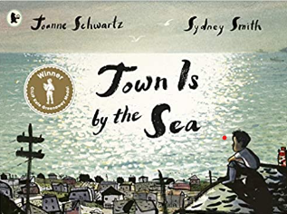

**ART**

**We will be looking at a range of skills through:**

* **Painting**
* **Sketching**

**DT**

* **We will be looking at making a model of the pit head stocks at Clipstone which includes a pulley system**



**Spanish**

**We will learning about:**

* **Colours**
* **Numbers**
* **Animals**
* **Seasons**