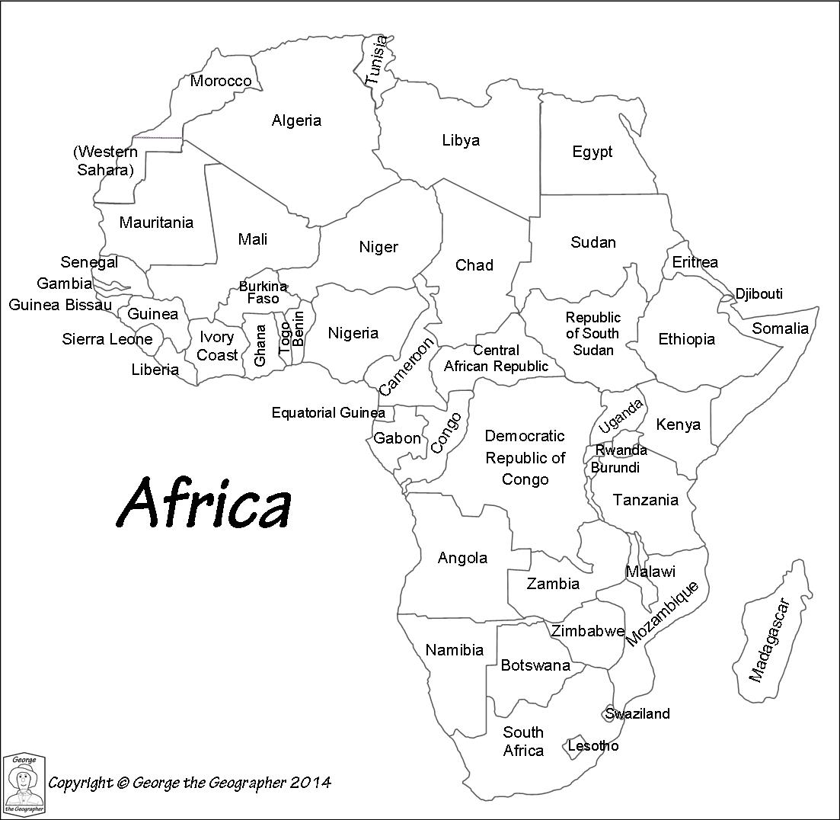

**Science**

Through learning about functions of the eye, shadows and mirrors, we will begin to understand the journey of light. We will also learn how we can use mirrors to change the direction light travels in. We will also see if we can change shadows.

**P.E.**

This term will see us further develop our gymnastics skills through the use of apparatus. We will also develop our cricket, netball and orienteering skills.

**Geography**

We will identify countries and regions within Africa. For each region, we will learn about the longest rivers, highest mountains, climates and natural resources available. We will learn about the oceans and seas that surround Africa and how countries within the continent are developing in different ways.

**R.E.**

We will learn about Mahatma Gandhi, an inspirational person, understanding his policy of non-violent, peaceful protest and how he supported the human rights of all people. We will also understand the roles played by significant people during Holy Week (Easter).

**Music**

We will develop our use of untuned instruments by playing the glockenspiel. We will also learn about the importance of women in the music industry.

**Citizenship**

We will focus on preparing to become a responsible future citizen. Within our work, we will recognise that by working together, harmony can be created and common goals achieved. During this work, we will research the impact of the work of the United Nations (U.N.) on peace, rights and freedoms for all. We will also understand the work of the European Parliament.

**English**

**Writing**

This term we will write a setting description and a character description. Even though ‘Holes’ links to Crime and Punishment, we love it so much we will start to base our writing on it during this topic.

**Reading**

We will read a variety of texts to improve our comprehension skills focusing on VIPERS, as well as reading numerous texts, folklore and legends from Africa.

**SPaG**

We will continue to learn and apply a range of grammar and spelling rules.

**Computing**

Our work during this topic sees us understanding the journey of a web page. We will learn how search engines rank results. We will understand the importance of Tim Berners-Lee on our lives. We will also learn how spreadsheets and graphing software work.

**History**

We will be able to understand how slavery developed from the 15oos until its abolition in 1833. We will also learn about the Zulu kingdom, finishing off our work by learning about apartheid in South Africa. As always, we will identify how this part of our history still impacts on us.

**Africa**

**Maths**

We will develop fluency, reasoning and problem-solving skills in the areas of:

* Measurement
* Geometry – Circles, property of shapes, angles
* Statistics
* Algebra
* Geometry: reflection, translation/position & direction
* Ratio and Proportion

We will continue to practise our arithmetic, four operations, rapid recall and times tables skills on a weekly basis.

**Art**

Our artwork will see us learn to weave ‘Kente’ cloth. When painting, we will use a variety of paints and techniques to paint in the styles of different artists (using oils and watercolours in particular).