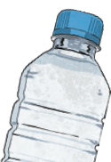
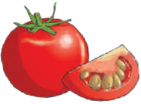
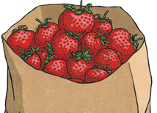
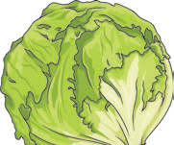
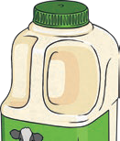
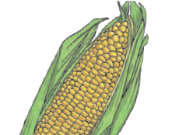
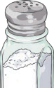

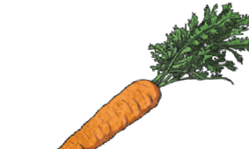
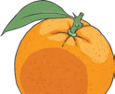
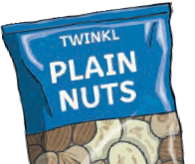
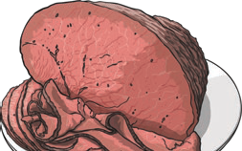
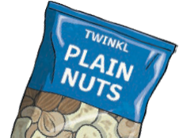
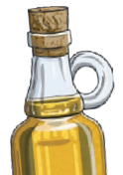
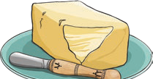
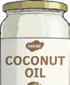
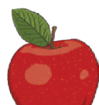
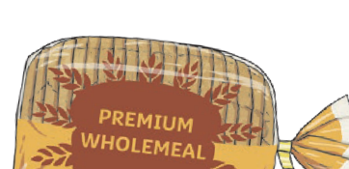
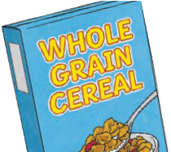
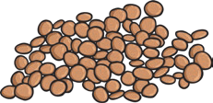
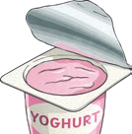
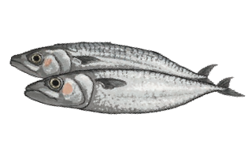
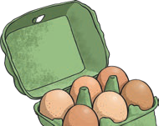
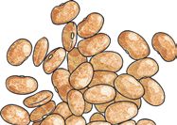
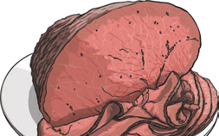
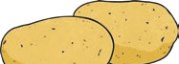
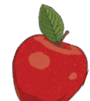
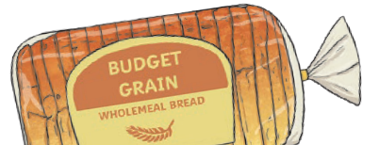
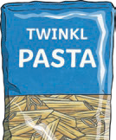
The diet we need to have to stay alive and healthy.

nutrition

nutrients

Substances that animals need to stay alive and healthy

Animals Including Humans
Year 3

Nutrient
Found in... (examples)
What it does/they do

carbohydrates

provide energy

protein

helps growth and repair

fibre

helps you to digest the food that you have eaten

fats

provide energy

vitamins

keep you healthy

minerals

keep you healthy

water

moves nutrients around your body and helps to get rid of waste

Key Vocabulary
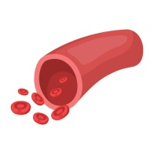
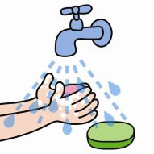
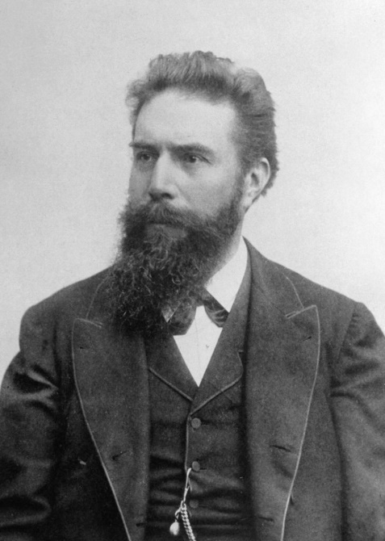
Blood vessels (veins and arteries) transport oxygen, water and nutrients around the body.
To stay healthy, humans need to exercise, eat and healthy diet and be hygienic.
Wilhelm Rontgen (Mechanic engineer and physicist) produced and detected electromagnetic radiation, also known as x-rays.
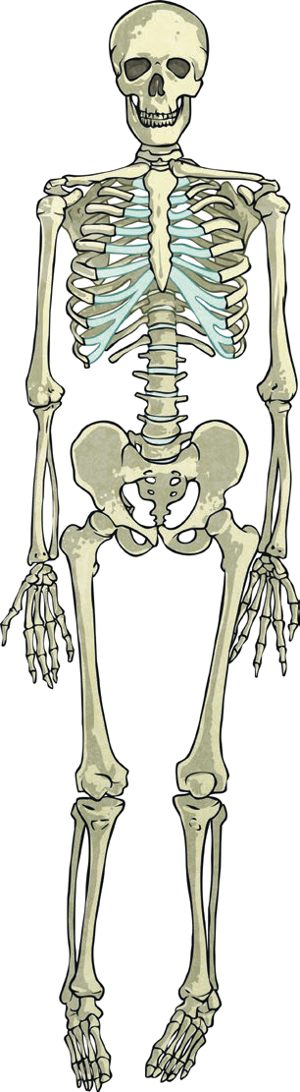
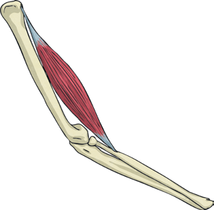
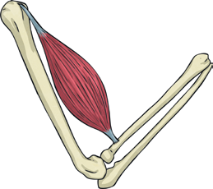
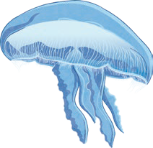
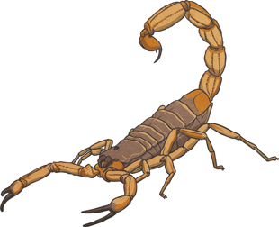
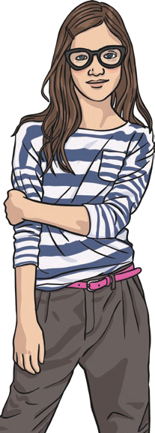
Our ribs protect our heart and lungs.
The skull protects our brain.
Invertebrates do not have skeletons like humans.
A vertebrate has a backbone.
vertebrate

endoskeleton

Bones
Animals Including Humans
Year 3

invertebrate

exoskeleton hydrostatic skeleton

Skeletal muscles work in pairs and are attached to bones by tendons. They contract (get shorter) and relax (get longer).

contract relax

skull

ribcage

pelvis
radius

femur

tibia fibula

Skeletons do three important jobs:
- protect organs inside the body;
- allow movement through joints and support the body.
We have 600 bones in our body!
Key Vocabulary
movement

protection

muscles

soft tissues in the body that contract and relax to cause movement

tendons

cords that join muscles to bones

joints

areas where two or more bones are fitted together

