Adolescence (teenager)
The body starts to change over a few years. The changes occur to enable reproduction during adulthood.
The pituitary gland and the hypothalamus start to make more of some hormones.
early adulthood
The human body is at its peak of fitness and strength.
childhood
Children learn new skills and become more independent.
fertilisation
The male and female sex cells fuse together.
middle adulthood Ability to reproduce decreases.
There may be hair loss or hair may turn grey.
old age
Leading a healthy lifestyle can help to slow down the decline in fitness and health which occurs during this stage.
infancy
Rapid growth and development. Children learn to walk and talk.
prenatal
The cells develop and grow into a foetus inside the mother’s uterus. After around nine months, the baby is born.
Animals Including Humans
mans
Key Knowledge
Year 5
Key Vocabulary
fertilisation
The process of the male and female sex cells fusing together.
prenatal
The stage of development from the time of fertilisation to the time of birth.
gestation
The process or time when prenatal development takes place before birth.
reproduce
To produce young.
asexual reproduction
A process where one parent produces new life.
sexual reproduction
A process where two parents – one male and one female – are required to produce new life.
life cycle
The changes a living thing goes through, including reproduction.

.
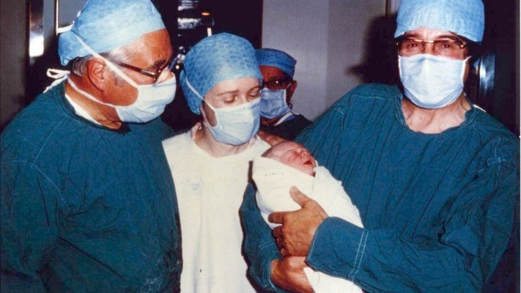
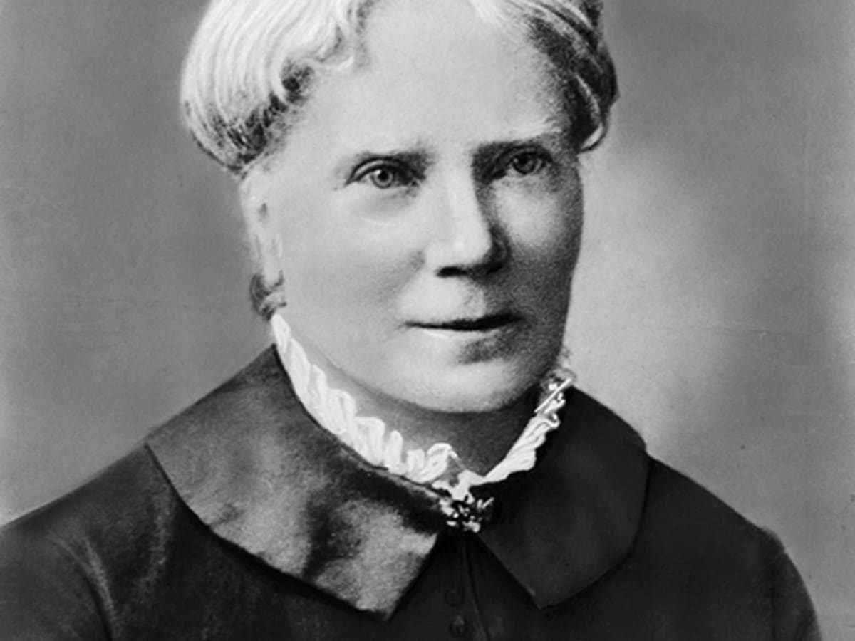
Patrick Steptoe, Robert Edwards and Jean Purdy (Obstetrician, Physiologist and Embryologist) looked at fertility treatment and created the first test-tube baby.
Elizabeth Blackwell (Doctor) pioneered the role of women in medicine. She became the first woman to get a medical degree in the USA after being refused in the UK.
The changes can be emotional or physical.

Both sexes will grow taller and their sweat glands will produce more sweat, creating body odour.

Hormones control these changes.
become more muscular
scrotum, testes and penis develop
grow facial hair
larynx (voice box) grows - ‘Adam’s apple’
- Voice breaks.
grow hair under armpits
gain hair on arms and legs
skin becomes oilier, which can lead to spots.
grow hair on chest
grow pubic hair
Puberty for boys:

Puberty for girls:

grow pubic hair
gain hair on arms and legs
grow breasts
grow hair under armpits
skin becomes oilier, which can lead to spots.
start to menstruate
larynx (voice box) grows
Animals Including Humans
Year 5
Key Vocabulary
adolescence
The social and emotional stage of development between childhood and adulthood.
puberty
The physical stage of development between childhood and adulthood.
menstruation
When the female body discharges the lining of the uterus. This happens approximately once a month.
adulthood
The stage of development when a human is fully grown and mature.
life expectancy
The length of time, on average, that a particular animal is expected to live.
Key Knowledge

