**Intent, implementation and impact statements**

**MFL (Spanish) at Newlands**

**Intent**

At Newlands, we aim to stimulate and encourage curiosity in other languages and cultures to enable our children to celebrate and welcome cultural differences in our world.

We want our pupils to have progressively covered the skills and concepts required in the National Curriculum. We aim to develop Spanish skills and concepts that are transferable to whatever aspect of MFL is being studied to equip children for future learning and to promote a passion for other cultures and languages. These key Spanish skills and concepts are: listening, speaking, reading, writing, grammar and cultural understanding.

The intent in lower KS2 is that children will begin to understand and respond to both spoken and written language by joining in with simple conversations, writing simple sentences and engaging in songs and rhymes.

In upper KS2, the intent is that children will speak, read and write Spanish with increasing confidence, fluency and spontaneity. Through broadening vocabulary and grammar knowledge, children will find ways of communicating what they want to say with improving pronunciation and intonation. Children will engage in more challenging conversations, ask and respond to questions and write and read sentences that are more complex.

**Implementation**

The teaching of Spanish is approached through multi-sensory, interactive learning where children are equipped to listen, understand and respond. We use an online scheme of work alongside additional materials to ensure that learning opportunities are engaging and varied and that children have access to hearing native speakers.

In order for children to know more and remember more in each area of Spanish studied, prior knowledge is always considered and opportunities for the use of known words and phrases are built into lessons wherever possible. This constant revision of key vocabulary and grammar helps build a depth to children’s understanding and their ability to use the Spanish language. In additional to revision opportunities, each unit introduces new skills and challenges.

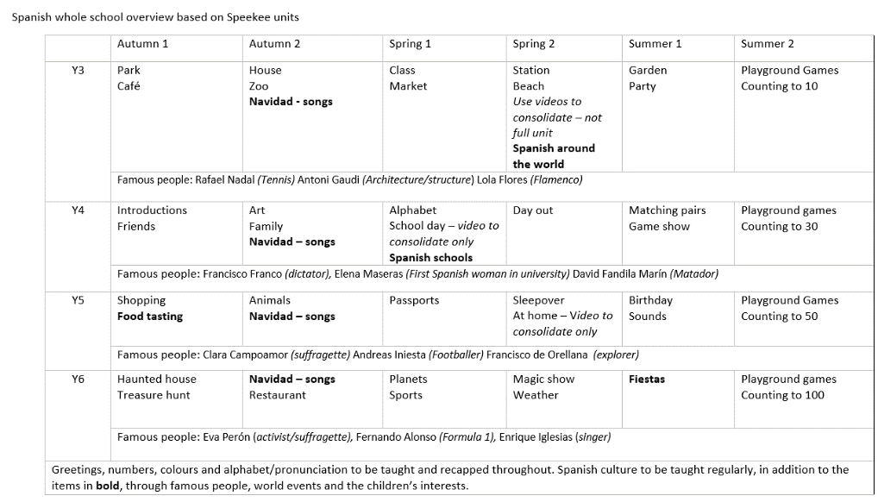Through our Spanish lessons at Newlands, we intend to inspire pupils and teachers to develop a love of Spanish and broaden our understanding of the world in which we live.

**Impact**

We encourage our children to enjoy and value the curriculum we deliver. We want learners to discuss, reflect and appreciate the impact Spanish has on their learning, lives, development and well-being. The impact of using a wide range of resources will be seen across our school, with an increase in the profile of Spanish.

Learning environments across the school will display Spanish vocabulary, which will be spoken and used by all learners. We want to ensure that teachers and pupils love Spanish across Newlands. Encouraging pupils to want to continue building on this wealth of knowledge and understanding, now and in the future.

Progress within our Spanish curriculum is demonstrated through outcomes and the record of coverage in the process of achieving these outcomes. A variety of evidence for these outcomes can be seen published in children’s MFL books, on big sheets, in photographs and on the school website.