Summer activities for Year 6 children
There are things you can do at home to help you manage some of the things you need to do once you start your secondary school. How many of these can you do over the summer to get ready for your time in secondary school?
Activity | I have done this √

Walk the journey you will take to school – go with an adult and walk the way you will go to school. Where will you cross the roads safely?
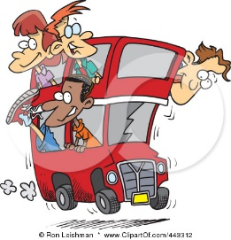
If you are going to catch a bus to school can you get on a bus and pay the fare by yourself (an adult could get on behind you and pay their own bus fare). It’s good to be able to do this even if you won’t need to pay bus fare on your school bus.

Go into a shop and buy something by yourself. Make sure you can go to the till and pay for something on your own because at school you might need to pay for something or go to a student support desk to ask for help on your own.

Visit a café or restaurant and order something from the menu without an adult helping you. This will help you manage asking for food at lunch time at secondary school.


Tie a tie so you know how to do it after PE lessons and every day in the morning. There are YouTube videos if you haven’t got an adult who can show you at home.
https://youtu.be/xAg7z6u4NE8?t=10

If you’re really lucky, your school might insist on clip on ties!


Go to the shops with a small list of things to buy – this will help you remember things and help you practise being organised for secondary school.

Follow a simple recipe – in some of your lessons, teachers will give you instructions to follow on your own, so a recipe is a good way to practise this.
This Photo by Unknown Author is licensed under CC BY-ND
Remember to be supervised if you are using the oven or hob.

Put emergency numbers into your phone – parents, other family members who you could phone if you need help.
Put the school number in too – you might need it or need to give it to someone.
If you don’t have a phone, make a list of emergency numbers to keep in your school bag.
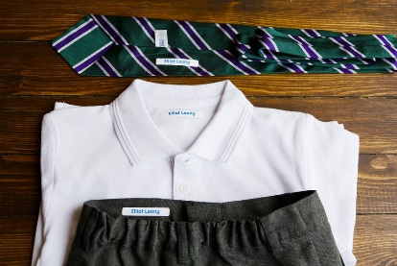
Put your name in your uniform.
You can buy fabric pens to write your name in so your parent doesn’t have to do it – if you write it in yourself will know where it is written.
Remember secondary schools are bigger than primary schools so it will be harder to find your things if you lose them.
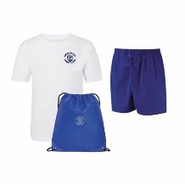
Put your name in your PE kit
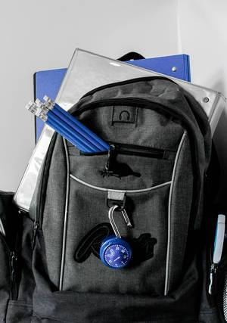
Pack all your equipment in your bag – pens, pencils, rulers etc
This Photo by Unknown Author is licensed under CC BY
Your secondary school will tell you what you need to take.
Don’t worry if your parent hasn’t been able to help you get all the things you need – you can let your tutor know when you start or email them, if you know their email address.

Show a grown up that you can cross the road safely.


Make an emergency plan in case you miss the bus or are late meeting your friends in the morning.
Write down what you will do if you miss the bus, or your friends aren’t there in the morning – how long will you wait? What will you do?
What if you miss the bus after school?
Write it down and put it in your bag or keep it as a note on your phone.

Waiting to start secondary school can be a mixture of feelings and that is the same for everyone. If you are feeling more worried or scared than you can manage, talk to an adult or someone who is already at secondary school. Grown ups can remember the feelings you are having, even if it is a long time ago! When you share your feelings, it helps your brain to manage them. Don’t worry on your own.

