
Schools & Families Specialist
Services
Sensory Team

Sensory Service

Useful Web based resources
Web address | Description of content
http://www.em-edsupport.org.uk/Page/10961  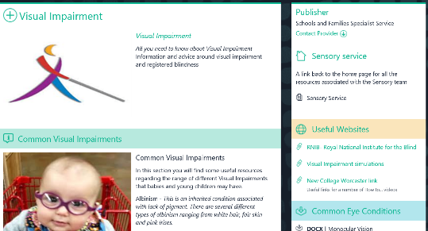 | - A web-based resource produced by the Sensory Team to support schools and families with a wide range of topics relating to Visually Impairment
https://www.rnib.org.uk/    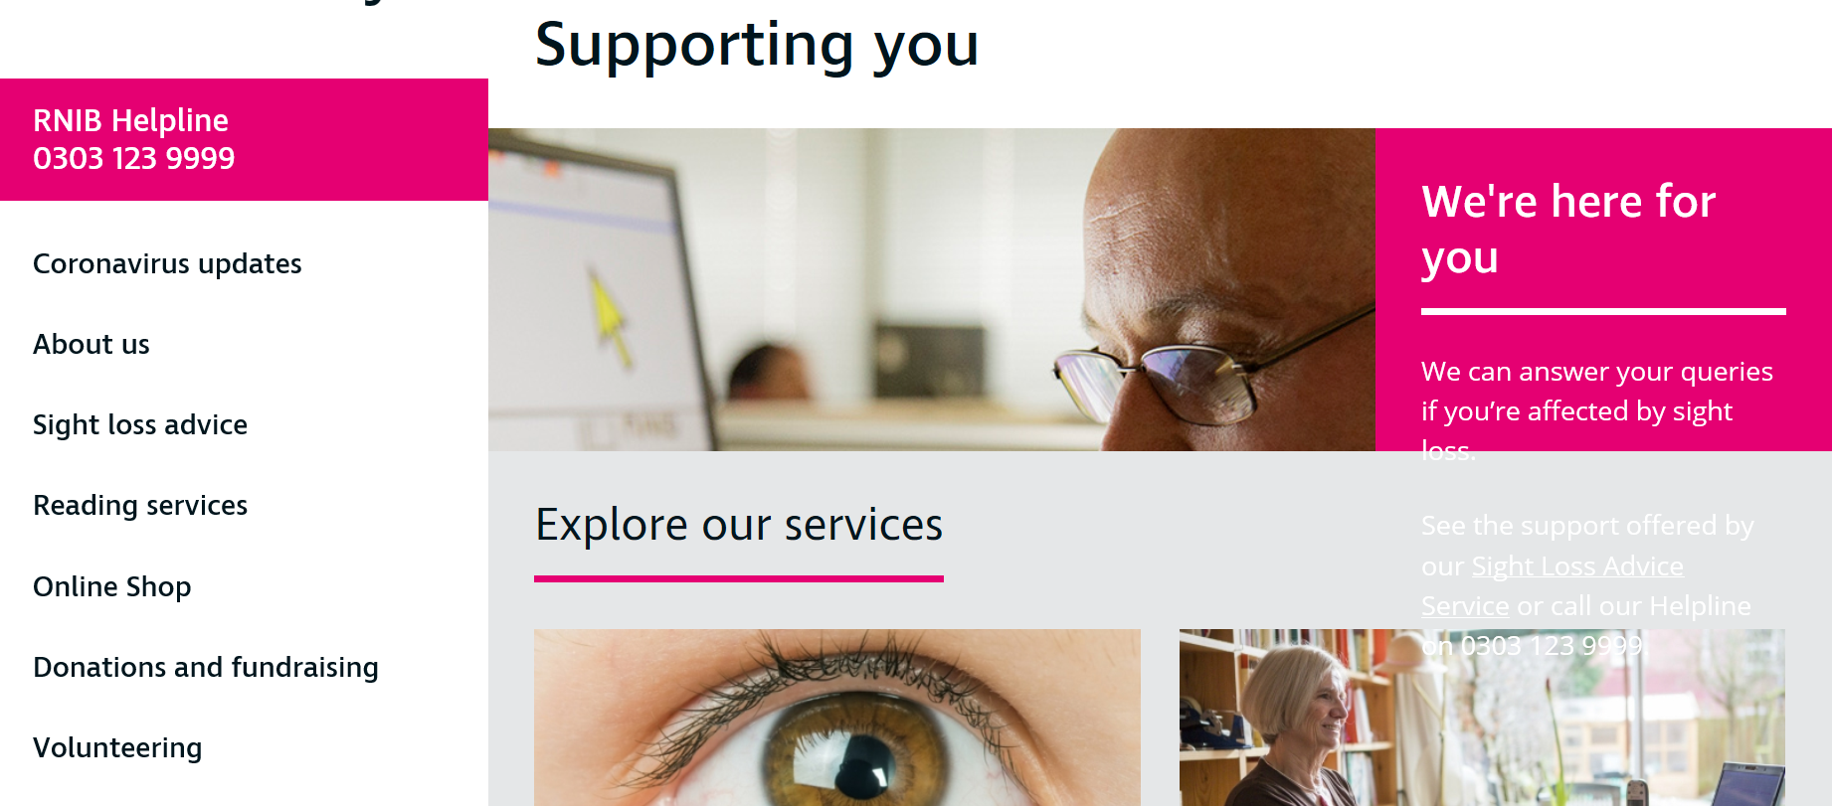 | - Royal National Institute for the Blind  Information on various publications around different aspects of Visual impairment and Blindness for Families, VI children and Young people and professionals
http://lowvisiononline.researchsoftware.  unimelb.edu.au/  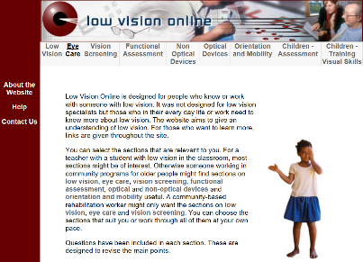 | - A website which has simulations of more common eye conditions
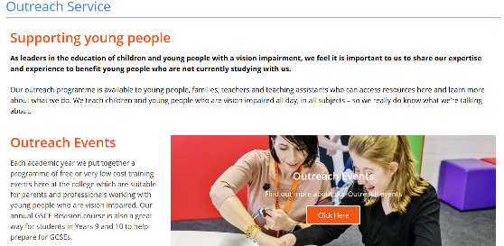  https://www.ncw.co.uk/services/outreach-service/ | - Useful links from New College Worcester offering outreach courses which are free or have a small cost
https://www.rnibbookshare.org/cms/  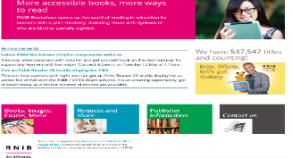 | - A Book Share Account from the RNIB can be set up. They offer a range of accessible formats that can be read electronically or adapted to a pupil’s preferred print size
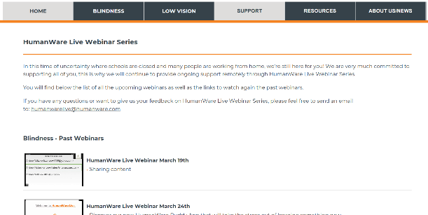  http://support.humanware.com/en-united_kingdom/support/humanware_live_webinar_series | - Humanware is the company that we use who provide much of the specialist equipment the SFSS loan to individuals in school. They offer support and web-based training which can be accessed by staff
http://www.clearvisionproject.org/  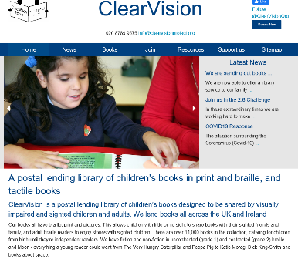 | - Information relating to a postal service for lending books in a variety of formats for pupils with Visual impairments
https://britishblindsport.org.uk/  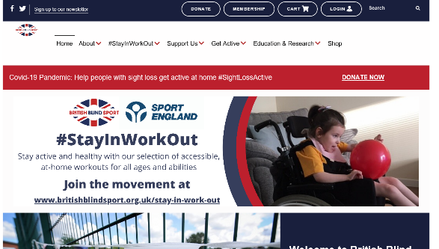 | - A website that looks at accessibility in Sport for VI pupils.
https://www.livingpaintings.org/  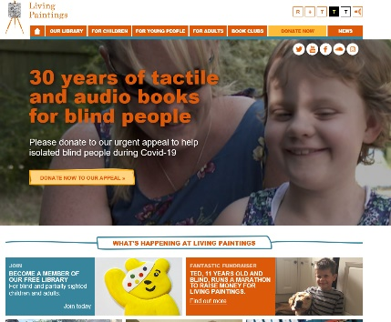 | - A charity in the UK who design, create and publish tactile and audio books for blind and partially sighted people. We call them Touch to See books. We publish titles suitable for anyone from pre-school to adult. We distribute these Touch to See books through our free postal library.
https://uebonline.org/  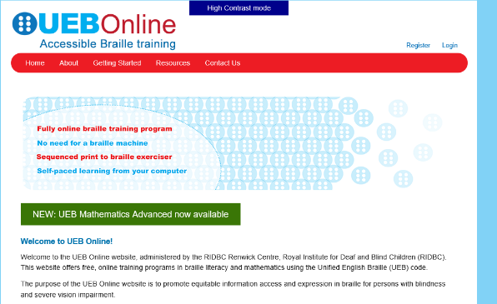 | - An accredited, free online training programme to learn Braille for maths and literacy using a laptop rather than a Perkins Brailler

