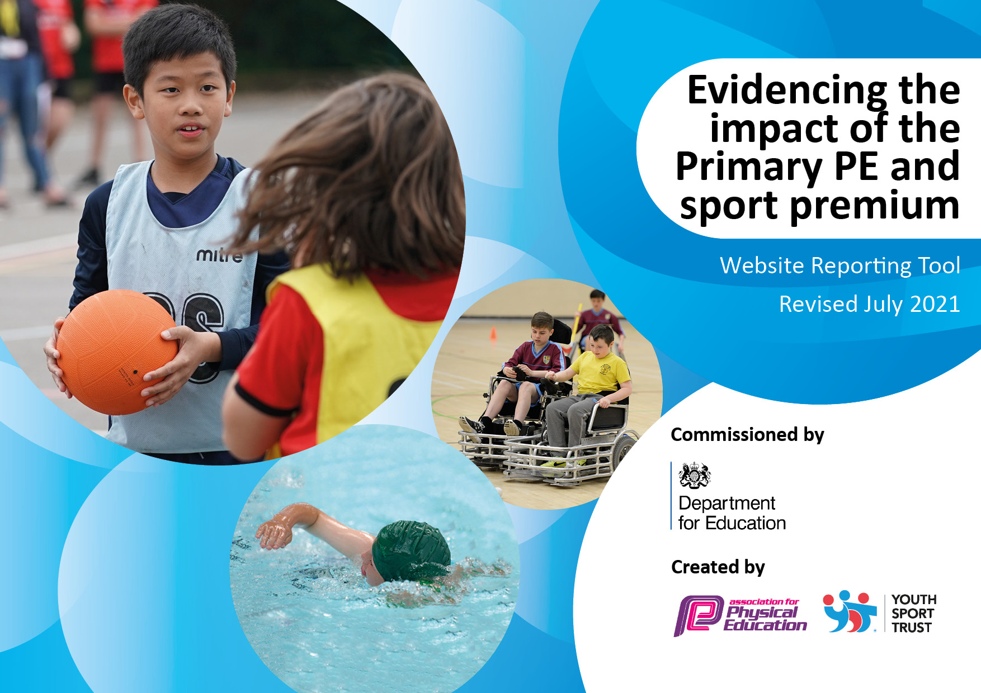

**REVIEWED JULY 2023**

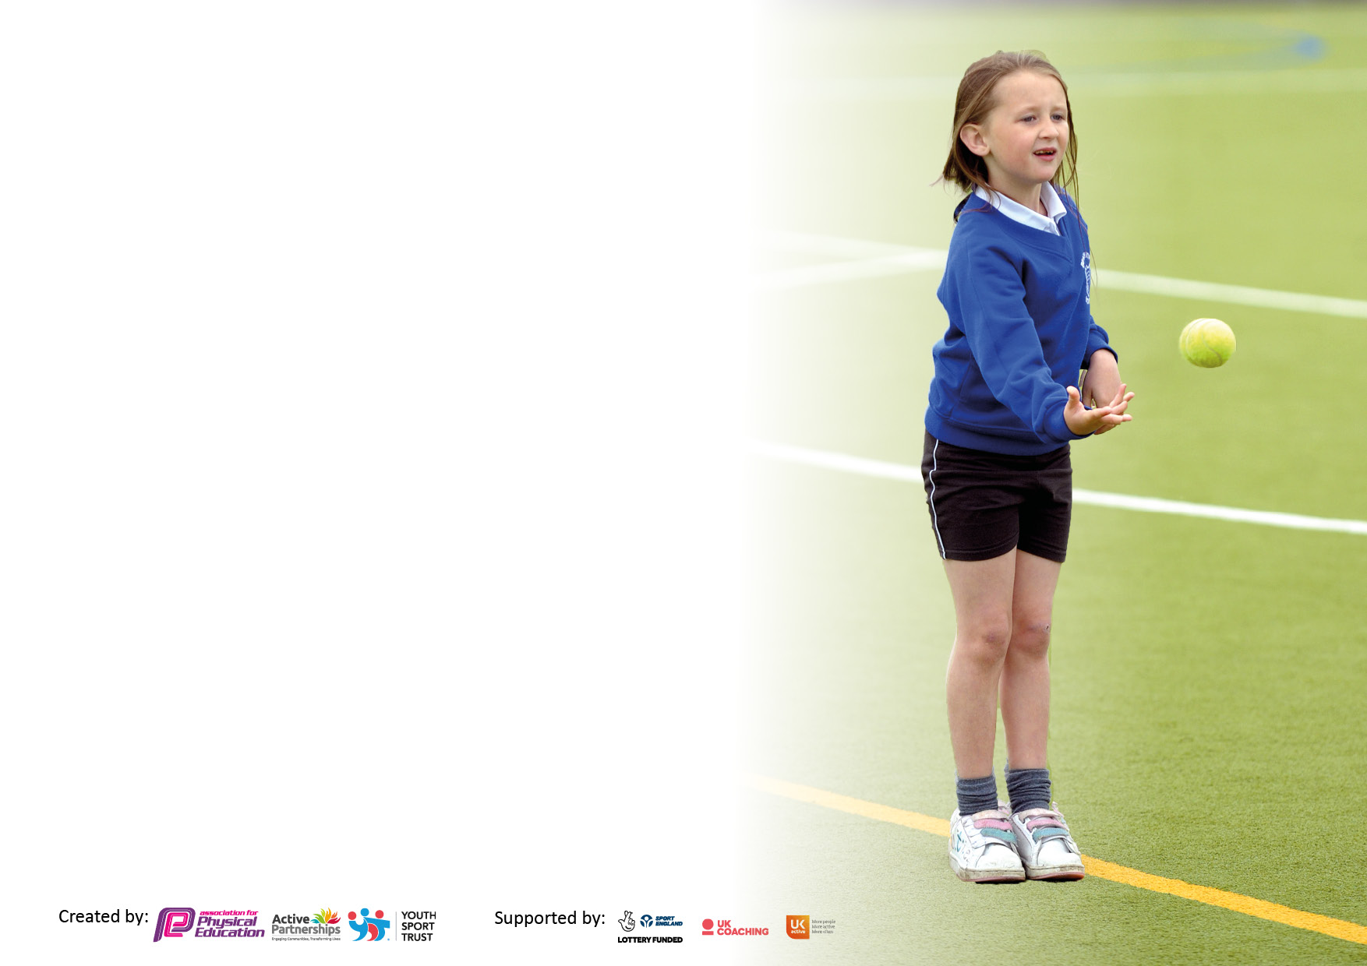

It is important that your grant is used effectively and based on school need. The Education Inspection Framework makes clear there will be a focus on **‘whether leaders and those responsible for governors all understand their respective roles and perform these in a way that enhances the effectiveness of the school’**.

Under the Quality of Education Ofsted inspectors consider:

**Intent** - Curriculum design, coverage and appropriateness

**Implementation** - Curriculum delivery, Teaching (pedagogy) and Assessment

**Impact** - Attainment and progress

To assist schools with common transferable language this template has been developed to utilise the same three headings which should make your plans easily transferable between working documents.

Schools must use the funding to make **additional and sustainable** improvements to the quality of Physical Education, School Sport and Physical Activity (PESSPA) they offer. This means that you should use the Primary PE and sport premium to:

* Develop or add to the PESSPA activities that your school already offer
* Build capacity and capability within the school to ensure that improvements made now will benefit pupils joining the school in future years
* The Primary PE and sport premium should not be used to fund capital spend projects; the school’s budget should fund these.

Pleasevisitgov.ukfortherevisedDfEguidanceincludingthe5keyindicatorsacrosswhichschoolsshoulddemonstrate animprovement.Thisdocumentwillhelpyoutoreviewyourprovisionandtoreportyourspend.DfEencouragesschools to use this template as an effective way of meeting the reporting requirements of the Primary PE and sport premium.

We recommend you start by reflecting on the impact of current provision and reviewing the previous spend.

Schools are required to publish details of how they spend this funding, including any under-spend from 2019/2020, as well as on the impact it has on pupils’ PE and sport participation and attainment. **All funding must be spent by 31st July 2023.**

We recommend regularly updating the table and publishing it on your website throughout the year. This evidences your ongoing self-evaluation of how you are using the funding to secure maximum, sustainable impact. Final copy must be posted on your website by the end of the academic year and no later than the 31st July 2023. To see an example of how to complete the table please click HERE.

Created by: Supported by:

**Details with regard to funding**

Please complete the table below.

|  |  |
| --- | --- |
| Total amount carried over from 2020/21 | £0 |
| Total amount allocated for 2021/22 | £17,929 |
| How much (if any) do you intend to carry over from this total fund into 2022/23? | £464 |
| Total amount allocated for 2022/23 | £18,146 |
| Total amount of funding for 2022/23. To be spent and reported on by 31st July 2022. | £18,610 |

**Swimming Data**

Please report on your Swimming Data below.

|  |  |
| --- | --- |
| Meeting national curriculum requirements for swimming and water safety.  N.B. Complete this section to your best ability. For example you might have practised safe self-rescue techniques on dry land which you can then transfer to the pool when school swimming restarts.  **Due to exceptional circumstances priority should be given to ensuring that pupils can perform safe self rescue even if they do not fully meet the first two requirements of the NC programme of study** |  |
| What percentage of your current Year 6 cohort swim competently, confidently and proficiently over a distance of at least 25 metres?  **N.B.** Even though your pupils may swim in another year please report on their attainment on leaving primary school at the end of the summer term 2021.  Please see note above | 70% |
| What percentage of your current Year 6 cohort use a range of strokes effectively [for example, front crawl, backstroke and breaststroke]?  Please see note above | 55% |
| **What percentage of your current Year 6 cohort perform safe self-rescue in different water-based situations?** | 78% |
| Schools can choose to use the Primary PE and sport premium to provide additional provision for swimming but this must be for activity **over and above** the national curriculum requirements. Have you used it in this way? | **No** |

**Action Plan and Budget Tracking**

Capture your intended annual spend against the 5 key indicators. Clarify the success criteria and evidence of impact that you intend to measure to evaluate for pupils today and for the future.

|  |  |  |  |  |
| --- | --- | --- | --- | --- |
| **Academic Year: 2022/23** | **Total fund allocated: £18,610** | **Date Updated: 31/7/23** | |  |
| **Key indicator 1:** The engagement of all pupils in regular physical activity – Chief Medical Officers guidelines recommend that primary school pupils undertake at least 30 minutes of physical activity a day in school | | | | Percentage of total allocation: |
| 27% |
| **Intent** | **Implementation** | | **Impact** |  |
| Your school focus should be clear what you want the pupils to know and be able to do and about  what they need to learn and to  consolidate through practice: | Make sure your actions to achieve are linked to your intentions: | Funding allocated: | Evidence of impact: what do pupils now know and what can they now do? What has changed?: | Sustainability and suggested next steps: |
| Employ 2 play leaders to lead games and sporting activities with the “sports crew” at lunchtimes. | Increase participation in a wide range of group sports and games on a daily basis increasing fitness, participation and learning powers. Promote positive play through fun and competitive activities which will raise the heartrate and increase fitness. | £5,000  towards cost of staffing | A greater number of children will participate in physical activity throughout the day. This will also impact on well-being as endorphins are released.  Fitness will increase and physical activity will become part of everyday life. | The majority of children are fully engaged in activities at lunchtime – fitness has certainly increased as has their skills, knowledge and tactical awareness of a variety of sports. Next year, we are going to employ 3 play leaders so that this success will be built upon and sustained. |
| To develop the role of a sports coach to enhance physical activity across the school. | To provide ‘before school’ physical activities and to work alongside play leaders at lunchtime organising skill-based activities.  To work alongside teachers during the teaching of curriculum PE to further enhance staff CPD.  To work closely with the PE Co-ordinator to continue to raise standards across school. | To enhance children’s well being and their readiness for learning. To develop motor skills and co-ordination further through the focus on basic physical skills.  By working with staff through-out the school, a progression of skills is ensured and the knowledge and confidence of staff will increase.  Continuity in all areas of PE will be developed, opportunities for more external competitive experiences will be possible and the provision of physical activity will be raised even further. | The role of our sports coach is now fully entrenched within our PE teaching across school. Staff are benefitting from watching an expert in action, thus enriching their CPD and increasing their confidence.  Next year, the sports coach will continue to teach across school, thus developing the skills and know-how of the teachers even further. |
| **Key indicator 2:** The profile of PESSPA being raised across the school as a tool for whole school improvement | | | | Percentage of total allocation: |
| 25% |
| **Intent** | **Implementation** | | **Impact** |  |
| Your school focus should be clear: | Make sure your actions to achieve are linked to your intentions: | Funding allocated: | Evidence of impact: | Sustainability and suggested next steps: |
| Purchase equipment/playground markings in order to carry out the lunchtime activities and PE lessons.  (replace lost/old equipment, purchase other to widen provision and support events. | Increase enjoyment, amount of physical activity and participation in sporting activities at break and lunchtimes by ensuring the correct equipment is available and there is enough to enable whoever wants to join in to do so.  All sports taught during curriculum time will be correctly equipped so that standards will be raised. | £4,610  to support playleader/sports coach with games and activities at break and lunchtimes and PE lessons. | At lunchtimes participation will rise and enjoyment increase across sporting activities leading to a healthier lifestyle. This will impact on attitudes towards physical activity so it becomes a part of life in the future. Within lessons, the quality and amount of resources available will ensure that the teaching of skills will be raised even further. | The playground markings are now complete and the netball and basketball courts can be used, next year, both during lessons and lunchtimes. Extra exercise machines have been added onto the field and these are now in use. These will increase the enjoyment and fitness of the children for years to come. |

|  |  |  |  |  |
| --- | --- | --- | --- | --- |
| **Key indicator 3:** Increased confidence, knowledge and skills of all staff in teaching PE and sport | | | | Percentage of total allocation: |
| 16% |
| **Intent** | **Implementation** | | **Impact** |  |
| Your school focus should be clear: | Make sure your actions to achieve are linked to your intentions: | Funding allocated: | Evidence of impact: | Sustainability and suggested  next steps: |
| Sports coaches to teach lessons and work with staff to provide  professional development. | Continue to provide CPD opportunities for all staff, ensuring that we employ coaches for a variety of sports to broaden and deepen the knowledge and confidence of staff. | £3,000 | Teachers are proficient in delivering high quality PE, differentiating where possible in a wider variety of sports. As a result, children are progressing in all strands of the PE curriculum, building on prior learning. | The staff continue to benefit from the expertise of the external coaches, who will continue to come into school next year (dance and tennis). The staff will be confident to tackle these activities if we dispensed with the  coaches at any future date. |
| **Key indicator 4:** Broader experience of a range of sports and activities offered to all pupils | | | | Percentage of total allocation: |
| 28% |
| **Intent** | **Implementation** | | **Impact** |  |
| Your school focus should be clear: | Make sure your actions to achieve are linked to your intentions: | Funding allocated: | Evidence of impact: | Sustainability and suggested  next steps: |
| Provision of sports after school clubs | Continue to offer a wide range of after school sports clubs, delivered by school staff and outside providers.  To continue to encourage more children to take part in physical activity after school increasing fitness, a lifelong love of physical activity and developing cultural capital by widening access to new experiences.  To ensure children who are not able to access sports clubs out of school are able to access provision in school. | £4,000  e.g. Commando Joe, dance,  multi-sports, girls and boys football, badminton, table tennis, netball, long distance running | By offering this diverse selection of after school clubs, children’s enjoyment of physical activity will be enhanced so that the activity can become a part of their lifestyle. It will also develop the skills of talented pupils who will be signposted to different clubs where they can continue to develop.  More pupils (particularly Pupil Premium ) who do not have access to sporting activities out of school will have benefitted from the provision provided.  A wide variety of provision will at some point in the year meet the interest of the vast majority of children. | This year a variety of clubs have been offered: girls’ football, boys’ football, multi-sports, dance and badminton. In the future, our popular clubs will continue to be offered but we will look for opportunities to offer less mainstream activities so that we become more diverse. We want our ‘active’ clubs to appeal to all our children, no matter what their preferences. |
|  |  |  |  |  |

|  |  |  |  |  |
| --- | --- | --- | --- | --- |
| **Key indicator 5:** Increased participation in competitive sport | | | | Percentage of total allocation: |
| 11% |
| **Intent** | **Implementation** | | **Impact** |  |
| Your school focus should be clear: | Make sure your actions to achieve are linked to your intentions: | Funding allocated: | Evidence of impact: | Sustainability and suggested  next steps: |
| Enrol in Mansfield Sports Partnership to support curriculum leader.  Train sports crew to  lead activities across school.  Participation in Mansfield sports festivals and in school tournaments/competitions | Continue to increase participation in competitive sport between schools ( through the Mansfield Partnership) and within school encouraging participation regardless of ability.  To train a sports crew who will learn leadership skills that will enable them to equip, organise and lead activities with children at lunchtimes.  Continue to enhance personal development, fitness and mental well being through competitive sport, by learning the skills for teamwork, resilience, respect and following rules. | £500  West Notts. College Sports Crew– Nikki Biggs  £1,500  towards cost of travel to competitions | The fitness of children will have improved allowing them to compete and deliver their best performances which will also impact on mental well-being.  Leadership skills of listening, communicating and co-operating will be developed within the crew and disseminated to those with whom they work.  There will be an increase in the number of children involved in competitive sport both formally out of school and informally in school through inter-class and lunchtime competitions.  The vast majority of children will embed personal attributes of teamwork, fair play, respect, following rules which are essential across school life and as responsible citizens later in life. | We have had our best-ever year for inter-school competitions and the children have thoroughly enjoyed entering them. The children are becoming much more confident at being taken out of the school environment, travelling to an unknown venue and mixing with a variety of unfamiliar children – this will only get better and better.  Next year, we will continue this trend, entering as many competitions as possible catering for our very best athletes but also our SEN, PP and SEMH children.  Next year, it is our aim to train a ‘Sports Crew’ as this is something that did not take place this year. |

|  |  |
| --- | --- |
| Signed off by | |
| Head Teacher: | A.Castledine |
| Date: | 7.7.23 |
| Subject Leader: | Mrs Martin |
| Date: | 6.7.23 |
| Governor: | M. Herrinton |
| Date: | 19.7.23 |