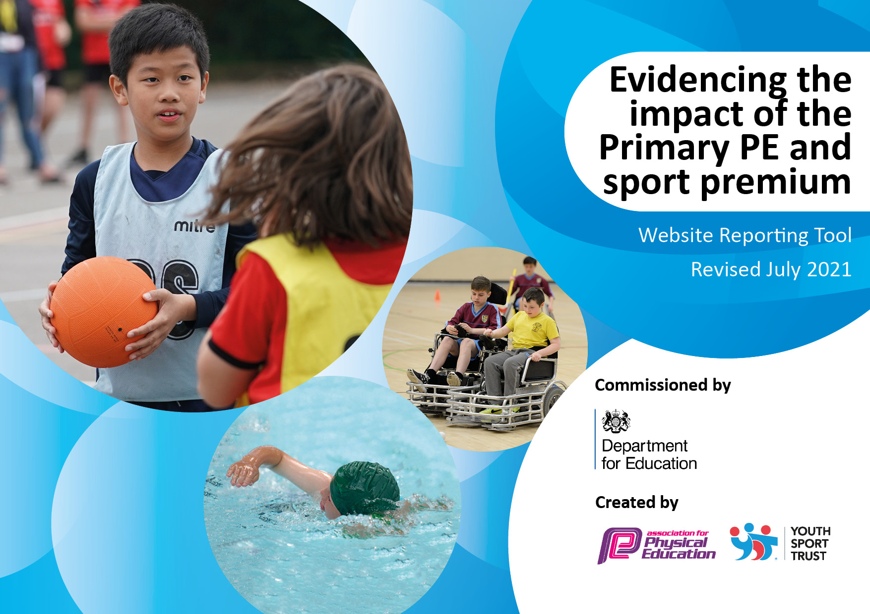

**REVIEWED JULY 2024**

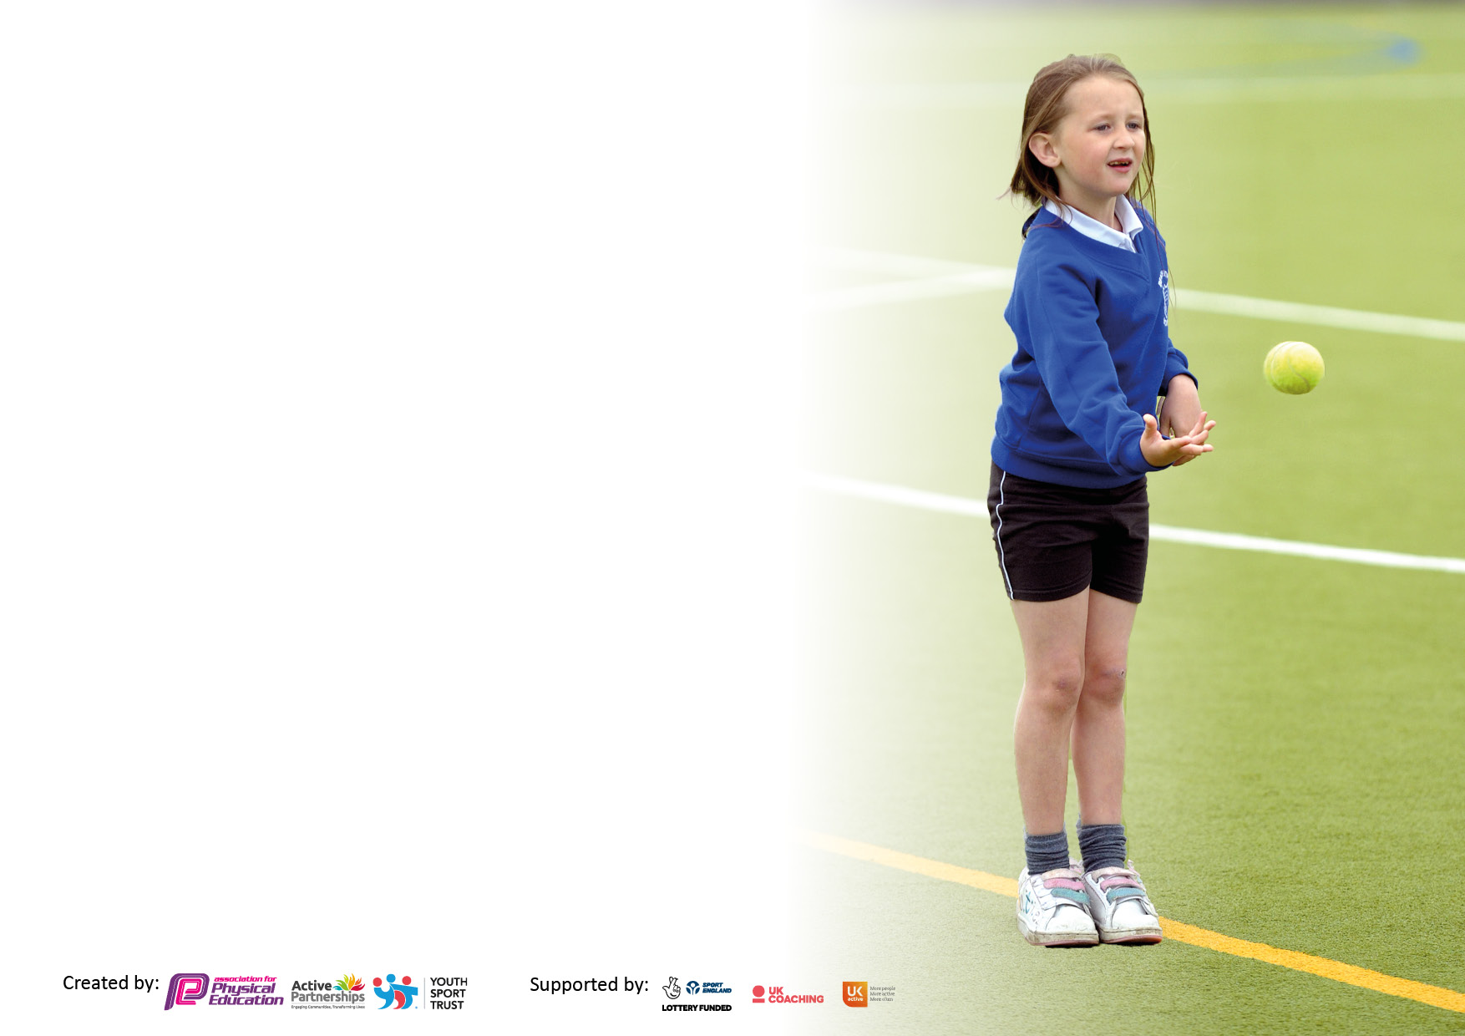

It is important that your grant is used effectively and based on school need. The Education Inspection Framework makes clear there will be a focus on **‘whether leaders and those responsible for governors all understand their respective roles and perform these in a way that enhances the effectiveness of the school’**.

Under the Quality of Education Ofsted inspectors consider:

**Intent** - Curriculum design, coverage and appropriateness

**Implementation** - Curriculum delivery, Teaching (pedagogy) and Assessment

**Impact** - Attainment and progress

To assist schools with common transferable language this template has been developed to utilise the same three headings which should make your plans easily transferable between working documents.

Schools must use the funding to make **additional and sustainable** improvements to the quality of Physical Education, School Sport and Physical Activity (PESSPA) they offer. This means that you should use the Primary PE and sport premium to:

* Develop or add to the PESSPA activities that your school already offer
* Build capacity and capability within the school to ensure that improvements made now will benefit pupils joining the school in future years
* The Primary PE and sport premium should not be used to fund capital spend projects; the school’s budget should fund these.

Pleasevisitgov.ukfortherevisedDfEguidanceincludingthe5keyindicatorsacrosswhichschoolsshoulddemonstrate animprovement.Thisdocumentwillhelpyoutoreviewyourprovisionandtoreportyourspend.DfEencouragesschools to use this template as an effective way of meeting the reporting requirements of the Primary PE and sport premium.

We recommend you start by reflecting on the impact of current provision and reviewing the previous spend.

Schools are required to publish details of how they spend this funding, including any under-spend from 2019/2020, as well as on the impact it has on pupils’ PE and sport participation and attainment. **All funding must be spent by 31st July 2023.**

We recommend regularly updating the table and publishing it on your website throughout the year. This evidences your ongoing self-evaluation of how you are using the funding to secure maximum, sustainable impact. Final copy must be posted on your website by the end of the academic year and no later than the 31st July 2023. To see an example of how to complete the table please click HERE.

Created by: Supported by:

**Details with regard to funding**

Please complete the table below.

|  |  |
| --- | --- |
| Total amount carried over from 2022/23 | £0 |
| Total amount allocated for 2022/23 | £17,929 |
| How much (if any) do you intend to carry over from this total fund into 2022/23? | £0 |
| Total amount allocated for 2023/24 | £18,146 |
| Total amount of funding for 2023/24. To be spent and reported on by 31st July 2024. 2023/24 | £18,146 |

**Swimming Data**

Please report on your Swimming Data below.

|  |  |
| --- | --- |
| Meeting national curriculum requirements for swimming and water safety.  N.B. Complete this section to your best ability. For example you might have practised safe self-rescue techniques on dry land which you can then transfer to the pool when school swimming restarts.  **Due to exceptional circumstances priority should be given to ensuring that pupils can perform safe self rescue even if they do not fully meet the first two requirements of the NC programme of study** |  |
| What percentage of your current Year 6 cohort swim competently, confidently and proficiently over a distance of at least 25 metres?  **N.B.** Even though your pupils may swim in another year please report on their attainment on leaving primary school at the end of the summer term 2024.  Please see note above | 54% |
| What percentage of your current Year 6 cohort use a range of strokes effectively [for example, front crawl, backstroke and breaststroke]?  Please see note above | 46% |
| **What percentage of your current Year 6 cohort perform safe self-rescue in different water-based situations?** | 54% |
| Schools can choose to use the Primary PE and sport premium to provide additional provision for swimming but this must be for activity **over and above** the national curriculum requirements. Have you used it in this way? | No |

**Action Plan and Budget Tracking**

Capture your intended annual spend against the 5 key indicators. Clarify the success criteria and evidence of impact that you intend to measure to evaluate for pupils today and for the future.

|  |  |  |  |  |
| --- | --- | --- | --- | --- |
| **Academic Year: 2023/24** | **Total fund allocated: £18,146** | **Date Updated: 5/7/24** | |  |
| **Key indicator 1:** The engagement of all pupils in regular physical activity – Chief Medical Officers guidelines recommend that primary school pupils undertake at least 30 minutes of physical activity a day in school | | | | Percentage of total allocation: |
| 27% |
| **Intent** | **Implementation** | | **Impact** |  |
| Your school focus should be clear what you want the pupils to know and be able to do and about  what they need to learn and to  consolidate through practice: | Make sure your actions to achieve are linked to your intentions: | Funding allocated: | Evidence of impact: what do pupils now know and what can they now do? What has changed?: | Sustainability and suggested next steps: |
| Employ 3 play leaders to lead games and sporting activities with the ‘Sports Leaders’ at lunchtimes. | Continue to increase participation in sports and games on a daily basis further increasing fitness, participation and learning powers. Promote positive play through fun and competitive activities which will raise the heartrate and increase fitness. Also by offering a wide range of activities it will expand the children’s experience of a diverse range of sports. | £5,000  towards cost of staffing the play leaders | A greater number of children will participate in physical activity throughout the day. This will also impact on well-being and the development of confidence and self esteem. Fitness will increase alongside a positivity and enthusiasm for physical activity. The ‘Sports Leaders’ will develop their leadership skills whilst encouraging and supporting the younger children. | The majority of children are fully engaged in activities at lunchtime thus increasing fitness, skills and the tactical awareness of a variety of sports. Next year, we will train new ‘Sports Leaders’ so that this involvement of youth is sustained year on year. We will also be on the look out for new innovative ‘Active Minutes’ ideas. |
| Hire a range of sports coaches to enhance physical activity across the school. | To work alongside teachers during the teaching of curriculum PE to further enhance staff CPD.  To offer a range of After School clubs providing CPD to the staff helping.  To work closely with the PE Co-ordinator to continue to raise standards across school. | To enhance children’s well being and their readiness for learning. To develop motor skills and co-ordination further through the focus on basic physical skills.  By working with staff through-out the school, a progression of skills is ensured and the knowledge and confidence of staff will increase.  The children are offered a range of After School clubs that complement what is being taught in curriculum PE.  Continuity in all areas of PE will be developed, opportunities for more external competitive experiences will be possible and the provision of physical activity will be raised even further. | The role of our sports coach is established within our PE teaching across school with staff benefitting from watching an expert in action. This provides CPD opportunities and increases their confidence.  Next year, the sports coach will continue to teach across school, thus developing the skills and know-how of the teachers even further. |
| **Key indicator 2:** The profile of PESSPA being raised across the school as a tool for whole school improvement | | | | Percentage of total allocation: |
| 17% |
| **Intent** | **Implementation** | | **Impact** |  |
| Your school focus should be clear: | Make sure your actions to achieve are linked to your intentions: | Funding allocated: | Evidence of impact: | Sustainability and suggested next steps: |
| Purchase equipment in order to deliver high quality teaching at lunchtimes and during PE lessons ( replace lost/old equipment, purchase equipment for new activities and support events eg sports day). | Ensuring there is the correct and sufficient amount of equipment is paramount so that standards will be raised whether at lunchtimes or during PE sessions. As we continue to diversify the activities that we offer, we will have to buy accordingly. | £3146  to support playleader/sports coach with games and activities at break and lunchtimes and PE lessons. | Throughout school, participation will continue to rise and enjoyment increase. Our varied sporting activities will impact on attitudes towards physical activity so they think positively about being active in the future. Within lessons, the quality and amount of resources available will ensure that the teaching of skills will be raised even further. | Each activity and sport taught, both at lunchtimes and during curriculum PE, is very well resourced. Next year, we will continue to keep up these high standards by re-stocking, checking and forward thinking. |

|  |  |  |  |  |
| --- | --- | --- | --- | --- |
| **Key indicator 3:** Increased confidence, knowledge and skills of all staff in teaching PE and sport | | | | Percentage of total allocation: |
| 19% |
| **Intent** | **Implementation** | | **Impact** |  |
| Your school focus should be clear: | Make sure your actions to achieve are linked to your intentions: | Funding allocated: | Evidence of impact: | Sustainability and suggested  next steps: |
| Involve external sports coaches to teach curriculum PE sessions to each year group and work alongside staff thus providing professional development.  Develop the role of the PE Co-ordinator and the sports coach | In order to ensure CPD opportunities for all staff, we have employed a dance and tennis coach for two terms in order to increase teachers’ confidence and subject knowledge.  Develop the role and expertise of the PE Co-ordinator and sports coach through CPD which has involved attendance at The PE Conference, a Cricket Workshop and a meeting led by the SGO in the Mansfield Partnership. | £3,000  £500 | Teachers are proficient in delivering high quality PE, differentiating where possible in a wider variety of sports. As a result, children are progressing in all strands of the PE curriculum, building on prior learning.  The PE co-ordinator and sports coach will keep up-to-date with the latest  thinking in PE, share best practice  and feed-back to staff who are then kept informed of the latest developments | The staff have benefitted from the expertise of the external coaches. Next year, we feel suitably skilled as a staff to deliver tennis across the school so will dispense with the services of the coach. We will continue to receive CPD from a dance specialist to boost confidence even further. We will think ahead as to where future CPD opportunities will arise.    By keeping up to date with changes in PE, new initiatives and through the sharing of ideas the school is forever moving forward. Next year, we will look out for other CPD opportunities and meetings within the sports partnership |
| **Key indicator 4:** Broader experience of a range of sports and activities offered to all pupils | | | | Percentage of total allocation: |
| 22% |
| **Intent** | **Implementation** | | **Impact** |  |
| Your school focus should be clear: | Make sure your actions to achieve are linked to your intentions: | Funding allocated: | Evidence of impact: | Sustainability and suggested  next steps: |
| Organise sporting experiences on a range of sports from which our children will benefit.  Provide a variety of ‘After school’ clubs | Our children have experienced a ‘Golf’ Day in which each class enjoyed an hour-long session from an expert coach. Also we embraced Disability Week by employing a coach to spend the week in school teaching the skills for wheelchair basketball, tennis and archery. Having access to new experiences such as these we hope to develop cultural capital and to foster a love of physical activity.  We have continued to offer a wide range of after school sports clubs, delivered by school staff and outside providers. To ensure children who are not able to access sports clubs out of school are able to access provision in school. | £4,000  Golf Day and Wheelchair Sports  Dance, Boys and Girls Football, Multi-skills | By offering these niche sports we hope to raise the children’s awareness of the different activities that exist beyond the more traditional sports that they are familiar with. By doing this, it is hoped that interest could be sparked and seeds could be sown for participation in their future life.  By offering a selection of after school clubs, children’s enjoyment of physical activity will be enhanced so that the activity can become a part of their lifestyle. More pupils (particularly Pupil Premium ) who do not have access to sporting activities out of school will have benefitted from the provision provided. | Next year, we hope to diversify, once again, by looking out for other unique sporting experiences.  This year a variety of clubs have been offered: girls’ football, boys’ football, multi-sports and dance. In the future, our popular clubs will continue to be offered but we will look for opportunities to offer less mainstream activities so that we become more diverse. We want our ‘active’ clubs to appeal to all our children, no matter what their preferences. |
|  |  |  |  |  |

|  |  |  |  |  |
| --- | --- | --- | --- | --- |
| **Key indicator 5:** Increased participation in competitive sport | | | | Percentage of total allocation: |
| 16% |
| **Intent** | **Implementation** | | **Impact** |  |
| Your school focus should be clear: | Make sure your actions to achieve are linked to your intentions: | Funding allocated: | Evidence of impact: | Sustainability and suggested  next steps: |
| Enrol in Mansfield Sports Partnership to support curriculum leader.  Train sports crew to  lead activities across school.  Participation in Mansfield sports festivals and in school tournaments/competitions | Continue to increase participation in competitive sport between schools (through the Mansfield Partnership) and within school encouraging participation regardless of ability.  To train a sports crew who will learn leadership skills that will enable them to equip, organise and lead activities with children at lunchtimes.  Continue to enhance personal development, fitness and mental well being through competitive sport, by learning the skills for teamwork, resilience, respect and following rules. | £500  West Notts. College Sports Crew– Nikki Biggs  £2500  towards cost of travel to competitions | The fitness of children will have improved allowing them to compete and deliver their best performances which will also impact on mental well-being.  Leadership skills of listening, communicating and co-operating will be developed within the crew and disseminated to those with whom they work.  There will be an increase in the number of children involved in competitive sport both formally out of school and informally in school through inter-class and lunchtime competitions.  The vast majority of children will embed personal attributes of teamwork, fair play, respect, following rules which are essential across school life and as responsible citizens later in life. | We have sustained our high level of participation in inter-school competitions, which the children have thoroughly enjoyed. Year on year, as they build on past experiences, our children are becoming more confident and enthusiastic when attending these external events.  Next year, we will continue this trend, entering as many competitions as possible catering for our very best athletes but also our SEN, PP and SEMH children.  This year we have trained a Year 5 ‘Sports Crew’ who have organised, led and delivered activities to the younger children at lunchtime – something we will continue next year. |

|  |  |
| --- | --- |
| Signed off by | |
| Head Teacher: | A.Castledine |
| Date: | 4.7.24 |
| Subject Leader: | Mrs Martin |
| Date: | 4.7.24 |
| Governor: | M. Herrinton |
| Date: | 4.7.24 |