**CONFIDENTIAL: Application for free school meals and milk**



# Nottinghamshire County Council carries out free school meals eligibility assessments for a number of schools. Information about which schools are included in this service is available at [www.nottinghamshire.gov.uk/freeschoolmeals](http://www.nottinghamshire.gov.uk/freeschoolmeals)

**Your details**

Title

(Mr, Mrs, Ms First name(s) Surname Date of birth National Insurance Number

Miss, other)

**Address:**

|  |
| --- |
|  |

# Home telephone number Relationship to child(ren)

**Mobile telephone number**

**E**

**-**

**mail address**

**Children’s details**

Please

Child’s full name tick Name of school

|  |
| --- |
|  |
|  |
|  |
|  |
|  |
|  |

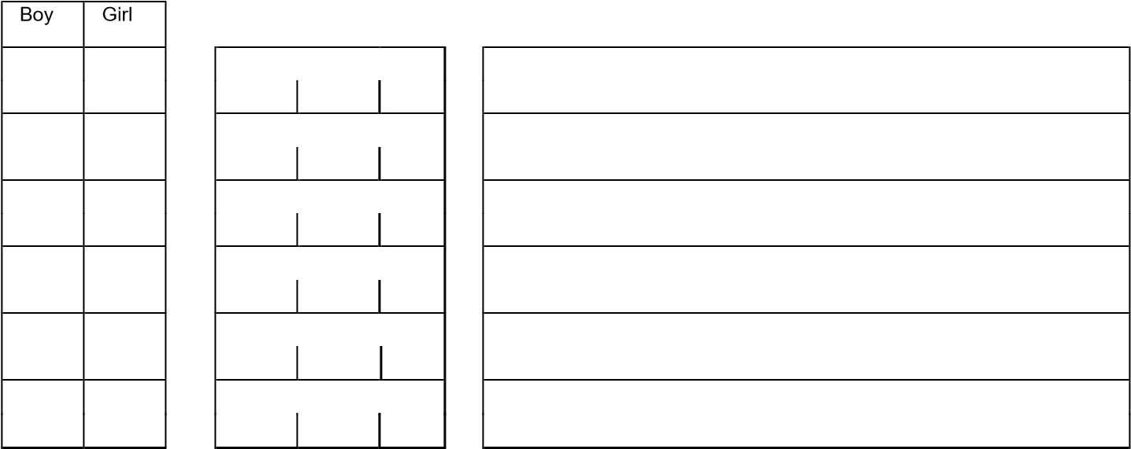 Date of birth

# You must sign the declaration below

The information I have given on this form is complete and accurate. I understand that my personal information is held securely and will only be used for local authority purposes. I agree to Nottinghamshire County Council using this information to process my application and carry out ongoing checks to determine my eligibility. I understand that the results of any free lunch eligibility check may be used to assess my entitlement to other pupil benefits including free school milk and school transport assistance.

|  |  |  |  |  |
| --- | --- | --- | --- | --- |
| **Your signature** | **Date** |  |  |  |

Please return to: Admissions and free school meals team, Meadow House, Littleworth, Mansfield, Nottinghamshire NG18 2TA or alternatively you can email to admissions.ed@nottscc.gov.uk For further information and advice contact 0300 500 80 80

|  |
| --- |
| It is important that all parents who receive one of the qualifying benefits listed below register for free school meals as this will enable your child’s school to claim pupil premium allocation.    **Free school meals eligibility criteria**     * Universal Credit (provided you have an annual net earned income of no more than £7,400, as assessed by earning from up to three of your most recent assessment periods) * Income Support * Income-based Jobseeker's Allowance (JSA) * Income-related Employment and Support Allowance (ESA) * Support under Part VI of the Immigration and Asylum Act 1999 * The guarantee element of Pension Credit * Child Tax Credit (with no Working Tax Credit) with an annual gross income of no more than £16,190 * Working Tax Credit run-on (paid for the four weeks after the person stops qualifying for Working Tax Credit)     Children who receive income support or income related employment support allowance in their own right are also eligible to receive free school meals (this situation often applies to post-16 pupils in special schools).  **Children moving to/from Nottinghamshire schools**  Children moving to a Nottinghamshire school who are covered by transitional protection will still need to apply to ensure that their free school meal eligibility is continued. Parents may be required to provide evidence of their transitional protection. For children leaving Nottinghamshire schools who are eligible, we will indicate in the stop letter to parents that their entitlement is covered by transitional protection.    **Other ways to apply**   * Apply online at [www.nottinghamshire.gov.uk](http://www.nottinghamshire.gov.uk/) * Apply by telephone 0300 500 80 80 |

Nottinghamshire County Council is committed to protecting your privacy and ensuring all personal information is kept confidential and safe. For more details see our general and service specific privacy notices at: <https://www.nottinghamshire.gov.uk/global-content/privacy/>